Name: ____________________________________ Date: ____________ Period: ______
Physical Science Review Solutions, Acids and Bases
Complete each question using your book, notes, or worksheets.
1. Name the parts of a solution:
a. The one that gets dissolved: ___________
b. The one that does the dissolving: ______________
2. What substance can dissolve many others, also called the universal solvent? ________
Why can it dissolve things so well? ________________________________
3. Name three factors that can increase the rate of dissolving (and the rate of many reaction as well)? a. _____________________ c. __________________________

b._____________________
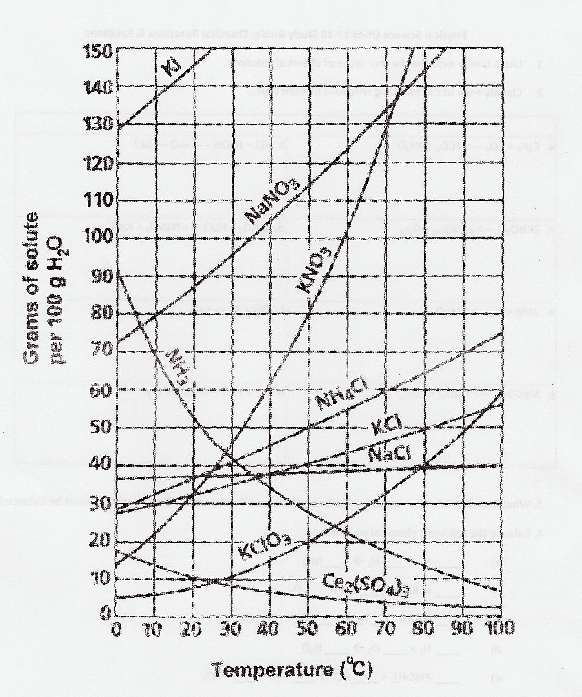
4. Use the solubility curve below to answer each question:
a. Which substance can dissolve 80 grams of solute in 50°C water? ______________

b. Which substance changes solubility the MOST during the temperatures shown? __________

c. When is the solubility of NH₃ higher, at low temperatures, or at high temperatures? ______

d. What type of solution of KCl will you have at 80°C if only 30 grams are dissolved?
_______________________

5. At what temperature does the solubility of NH₃ equal that of KClO₃?________

6. Which substances become less soluble as they get higher in temperature?
__________ & __________
7. An electrolyte is a substance which makes _____________ when it dissolves, and so its solution can ______________ ______________.

8. Fill in the table shown:
Characteristic | ACIDS | BASES
Ions it makes
Taste
pH values
9. Circle the 3 acids and put a box around the 3 bases:
HCl, Ammonia (NH₃), Mg(OH)₂, Sulfuric (H₂SO₄), Citric, Sodium hydroxide (NaOH)

10. Neutralization occurs when an acid is mixed with a base. Here is an example:
HCl + Ca(OH)₂ H₂O + CaCl₂ About what pH value will the products have? __

