Name: _________________________________________ Date: ______________ Period: ________
Unit 18 Notes: Solutions
- What is a Solution?
  - A ____________ that has the __________ composition, color, density throughout
  - Example: __________________
- Parts of a Solution
  - Solute- the substance ____________ ________________
  - Solvent- substance _____________ the _________________
  - 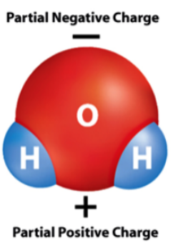Examples: soda, ocean water, _________, alloys- ____________ solution
- How Substances Dissolve
  - Dissolving something in ______________ Example: sugar water
  - Water is a ____________ molecule
    - Electrons ______________ unevenly
    - _______________ area and a ________________ area
  - Water molecules _____________ around sugar molecules
  - Water molecules __________ away at the sugar molecules
- Rate of Dissolving
  - 3 main ways to _______________ up the rate!

    - Increasing the ________________
    - Reducing crystal __________
      - ____________ __________
- How Much Can Dissolve?
  - How much sugar can you add to your tea?!?
  - Solubility- _______ amount of ___________ that can be dissolved in a given amount of __________
  - Concentration- quantity of ____________
    - A concentrated solution has ____________ of solute
  - Dilute Solution- ______________ have very much solute
  - Saturated Solutions- contains _______ the solute it can ___________ at a given _____________
  - Unsaturated Solutions- _______ dissolve more solute
  - Supersaturated Solutions- Contains ___________ solute than a _____________ solution at the same temperature

- Solubility Curves
  - 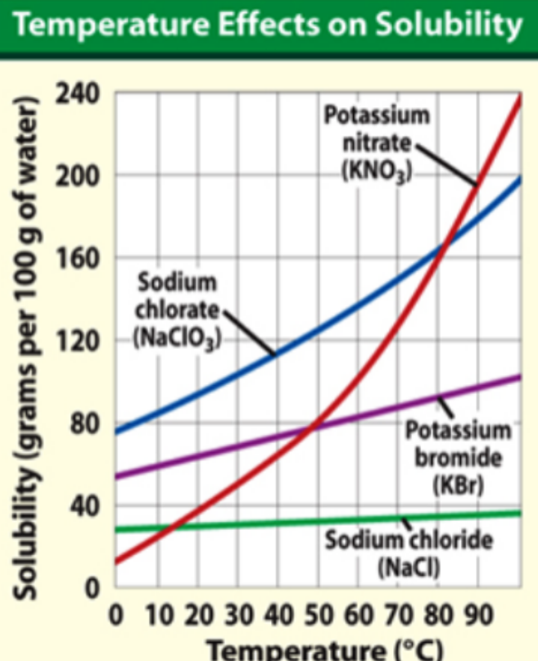Saturated- ___________________
  - Unsaturated- ____________________
  - Supersaturated- _____________________
What is the solubility of KNO₃ in 100 g of water at 50°C?

Is sodium chlorate unsaturated, saturated, or supersaturated if 100 grams are dissolved in 100 g at 50°C?

- Solubility Curve Practice
  - KNO₃- 40g at 40°C

  - KClO₃- 10g at 30°C

  - KCl- 60g at 90°C

  - NaCl- 50g at 30°C

