Name:_______________________ Date:________________
Honors Chemistry Take-Home Quiz on
Reaction Rates, Equilibrium, and Gas Laws
*Answer questions in complete sentences
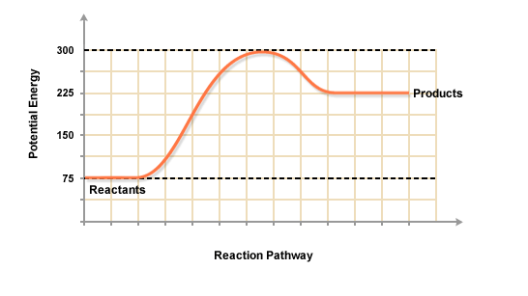
1. On the graph above, label range that represents the activation energy of this reaction. (2 pts)
2. On the graph above, draw a line that represent what this graph might look like if a catalyst were added to facilitate the reaction. (2 pts)
*3. Is this reaction endothermic or exothermic, and how do you know? (4 pts)

*4. Name five factors that can be used to speed up a chemical reaction. Using your notes, book and/or the internet as a resource, explain a real-life example of reaction rate manipulation. (8 pts)

For the following chemical equation at equilibrium:
H₂(g) + N₂(g) <--> NH₃(g)
5. Write the equilibrium expression. (2 pts)

*6. Name all the ways you could create more product using Le Chatelier’s Principle. (4 pts)

*7. If the pressure inside a balloon decreases from 100 kPa to 50 kPa at a constant temperature, what happens to the volume and why? (3 pts)

*8. What must happen to the temperature and pressure of the gas in order to decrease its volume?
(2 pts)

For the following gas law problems, please use the green formula sheet. Show your work! (3 pts)
9. If I have a 1.0-liter balloon that holds 2.00 moles at 1.02 atm, what must the temperature be in °C?

10. At a pressure of 1.05 atm and a temperature of 20.°C, a balloon has a volume of 5.0-L. What would the volume be if the pressure and the temperature decreased to 0.65 atm and -15°C, respectively?

11. A 200.-milliliter sample of a gas has a pressure of 1.00 atm. If the volume of the gas is decreased to 50. milliliters at constant temperature, what is the new pressure of the gas?

12. A sample of a gas occupies 6.00 liters at a temperature of 200. K. If the pressure remains constant and the temperature is raised to 600. K, what would the volume of the gas be?

